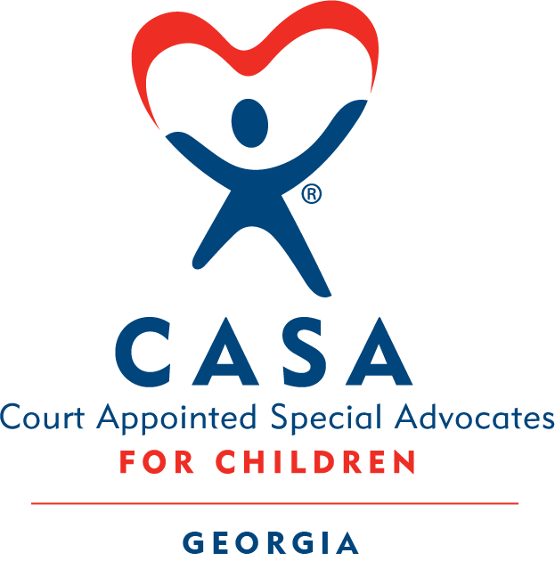

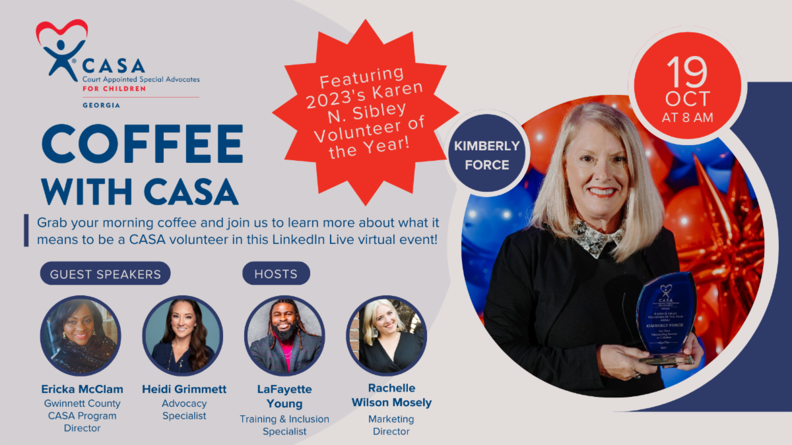

Greetings!

CASA volunteers empower the CASA mission of providing best-interest advocacy to children in foster care. In Georgia, this means that every day, over 2,500 people like you are uplifting the voices of thousands of children across the state.

But have you ever wondered how exactly a CASA volunteer does it? Tomorrow morning, we are hosting a virtual Coffee with CASA on LinkedIn Live. This conversation will provide a deeper look at the role of the volunteer and give you a chance to ask questions.

Guests bring a variety of perspectives and include:
- Kimberly Force, 2023 Karen N. Sibley Volunteer of the Year
- Ericka McClam, Gwinnett County CASA Program Director
- Heidi Grimmett, Georgia CASA Advocacy Specialist
- Dr. LaFayette Young, Georgia CASA Training & Inclusion Specialist
- Rachelle Mosely, Georgia CASA Marketing Director

We would love to connect with you tomorrow! Grab your coffee, bring your questions, and join us virtually at 8 a.m. tomorrow to learn more.

RSVP

Pssttt... Are you already in the CASA network? Forward this email to someone who you think would be a great fit for the CASA volunteer role.
﻿



